IAA-XX-14-0S-0P
NANOSATC-BR2 Thermal Simulation
Guilherme Paul Jaenisch*, Lucas Lourencena Caldas Franke*, Iago Camargo Silveira* Marcos Antônio Dal Piaz*, Maurício Ricardo Balestrini*, Tiago Travi Farias*, Otávio Santos Cupertino Durão**, Nelson Jorge Schuch*.

NANOSATC-BR2 is the second Brazilian scientific nanosatellite from the NANOSATC-BR Program, Development of CubeSats. This Program aims to contribute to capacitate Brazilians human resources in the satellite development and space researches areas by designing, developing platforms and payloads, test, launch and operates national scientific nanosatellites, which follows CubeSats standards. The Project has been designed and executed in a partnership between the Southern Regional Space Research Center (CRS) from the National Institute for Space Research (INPE-MCTI); the Santa Maria Space Science Laboratory, from the Federal University of Santa Maria (UFSM). This paper aims to present the NANOSATC-BR2 thermal simulation that has been done through finite difference in a specialized software called Sinda/Thermal Desktop. The simulation has been done in order to predict possible hot spots in the satellite, which can be very harmful for the mission, since all the electronic equipments have their own safe range of temperature to work perfectly. Also, as the NANOSATC-BR2 flies in an almost polar orbit (β = 98º), there is a huge difference regarding thermal loads, which may generate thermal gradients that cause thermal stress in the boards and in the mechanical structure of the satellite. Therefore, the simulation must be done in order to predict possible failures in the equipments and design a thermal control subsystem capable to prevent these possible failures in the mission. Results are presented.

- Introduction

The NANOSATC-BR Project - Development of CubeSats consists of a Training Program for Human Resources for developing with the Brazilian Space Research Engineering and Spatial Technologies as CubeSats, according According Schuch and Durão (2011), [2]. This project is developed in a partnership between the National Institute for Space Research CRS / INPE - MCTI and the Federal University of Santa Maria - UFSM through the Space Science Laboratory of Santa Maria - LACESM / UFSM, Figure 1.

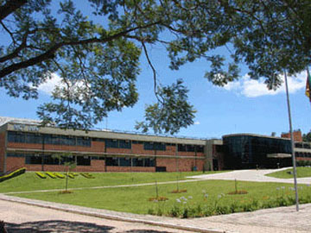

Figure 1: Centro Regional Sul de Pesquisas
Espaciais - CRS/INPE-MCTI, in Santa Maria, RS

The NANOSATC-BR project had its start with the design of the first Brazian nanosatellite, the NANOSATC-BR1. The development of this satellite increase the skills of several students UFSM in several areas of engineering and space science. With the success of the first project, the project had follow-up with the creation of NANOSATC-BR2. The CubeSats are characterized by having a cube-like shape, but the second nanosatellite project NANOSATC-BR has twenty-two inches tall and ten centimeters each edge of its base, featuring a 2U CubeSat. The NANOSATC-BR2 has been developed within a partnership with a specialized company - ISL / ISIS - Innovative Solutions in Space – being built in standard format in the class of Cubesats. It contains all devices which are mandatory for a satellite to work into space environment. It is split in two parts: bus and payload, and then respectively into other subsystem as it follows in the Figure 2 and Figure 3.

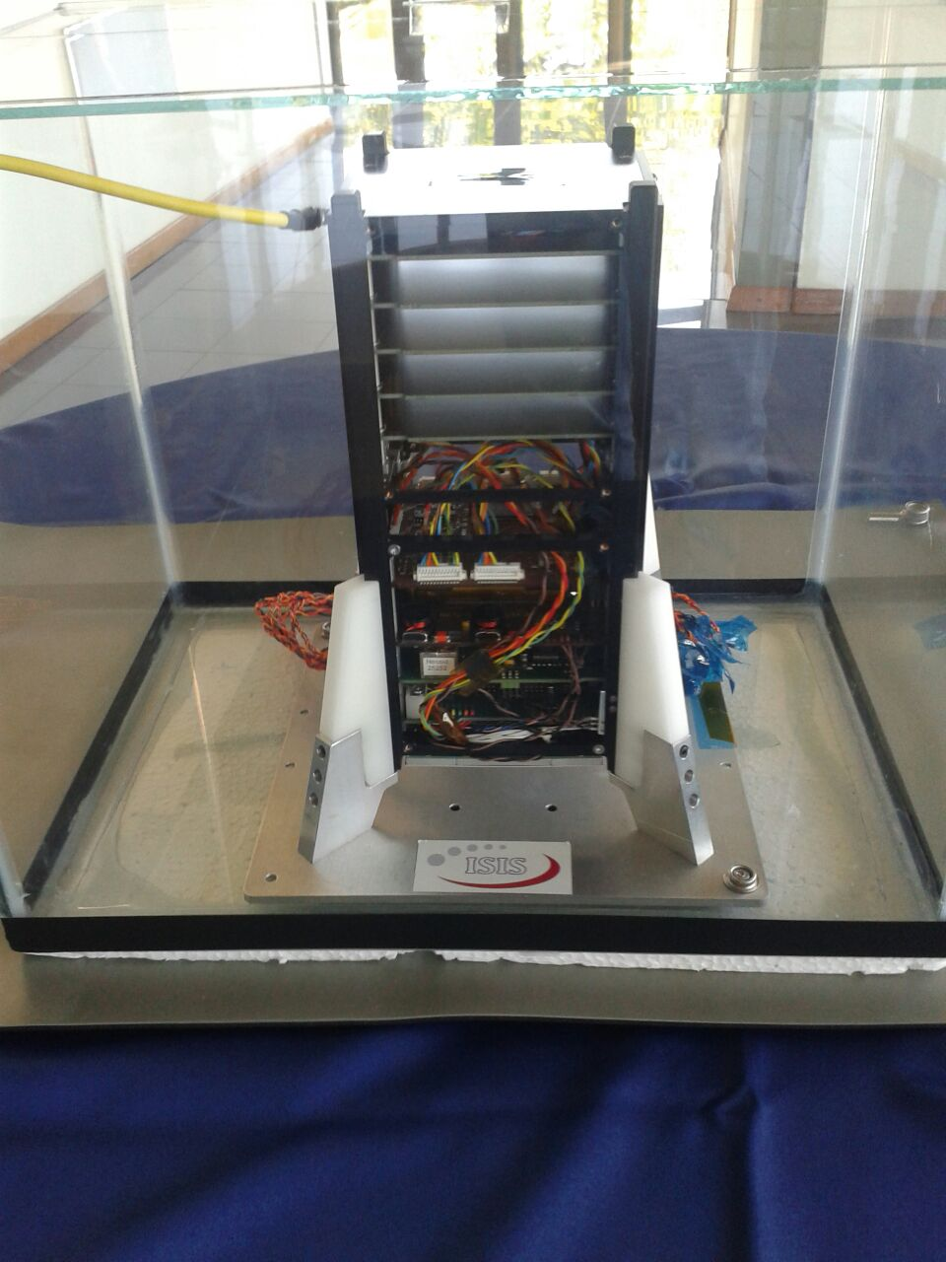

Figure 2: The CubeSat NANOSATC-BR2

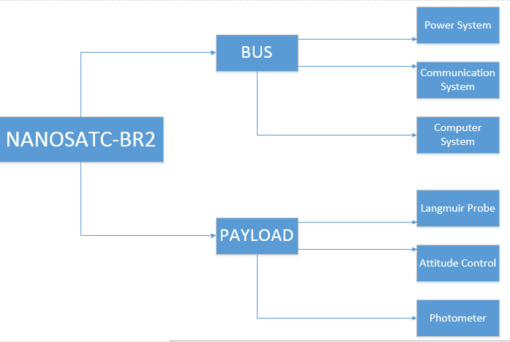

Figure 3: NANOSATC-BR2 scheme

- Theory

As the NANOSATC-BR2 will remain in space environment throughout its mission, the temperature gradients will be extremely rough, given that there are different heat loads interacting with the nanosatellite during its orbit. Four different heat loads must be considered, Figure 4:

- Solar Flux,
- Albedo,
- Earth infrared,
- Internal hear dissipation (through electrical components)

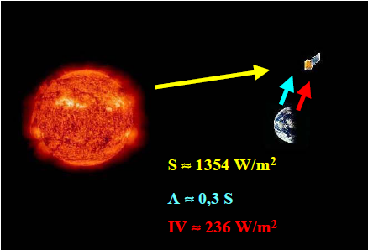
These heat loads can vary roughly throughout the NANOSATC-BR2 orbit and as consequence the thermal gradients generated through this heat loads variation can harm the internal equipment and in extreme cases cause the complete failure of the entire mission. In this case, the transference models involved in this mission are just conduction and radiation. It is necessary, therefore, to ensure the satellite can bear all thermal variation throughout its orbit. For doing so, the development of a numerical method is mandatory.
Figure 4: Four different heat loads
Fonte: De Sousa, et al. (2003-04), [1]. S = carga térmica Solar; A = Albedo; IV = Carga térmica emitida pela Terra no espectro Infra-Vermelho.

- Development

In order to develop a numerical model it is necessary to follow these five steps:

- Design the geometrical model;
- Set all the heat loads;
- Specify critical cases;
- Simulate the thermal charges variation throughout orbit;
- Check the results according to devices temperatures limits;

The geometrical model is done through a CAD platform in three dimension. The Figures 5, 6, 7 show the communication system, power system, on board computer system respectively. The payload system for the NANOSATC-BR2 was evaluated just as PCBs, which release heat, since, until the presentation of this work the payloads components were not still finished. Therefore, a balance was done
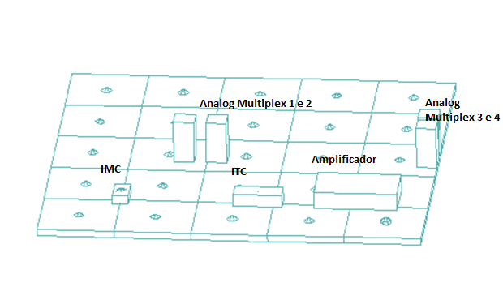
Figure 5: The geometrical model of Communication System is done through a CAD platform in three dimension

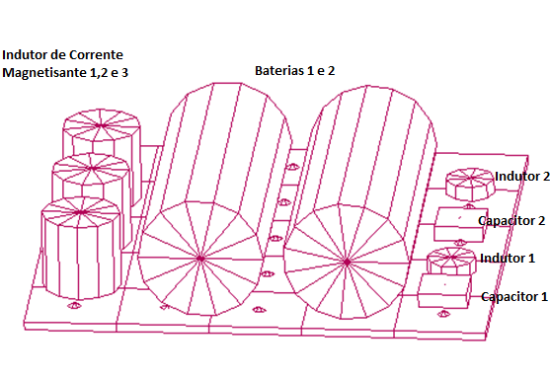
Figure 6: The geometrical model of Power System is done through a CAD platform in three dimension

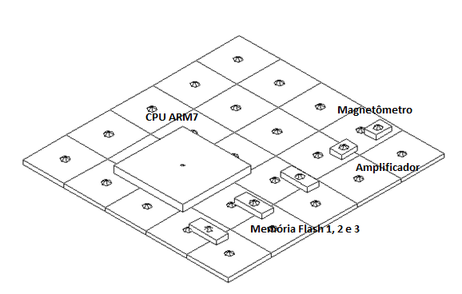
Figure 7: The geometrical model of On Board Computer is done through a CAD platform in three dimension

The main heat loads which interact with the satellite can be split into internal loads and external loads. The internal loads are the thermal dissipation of the electric components and the external loads are the solar flux, albedo and infrared, as prevsiouly exposed. The Table 1 expose all the internal loads:

Components dissipation of PCB TRANSEIVER
 |  | Standby (W) | Transmitting (W)
Analog Multiplex |  | 0.04 | 0.32
Amplificador |  | 0.04 | 0.32
IMC |  | 0.06 | 0.48
ITC |  | 0.06 | 0.48
TOTAL |  | 0.2 | 1.6
Components dissipation of PCB NANOPOWER
 | Standby (W) |  | Transmitting (W)
Bateries | 0 |  | 0
Heaters | 0 |  | 0,5
Inductor 1 | 0.05 |  | 0.05
Inductor 2 | 0.05 |  | 0.05
ICM1 | 0.05 |  | 0.05
ICM2 | 0.05 |  | 0.05
ICM3 | 0.05 |  | 0.05
TOTAL | 0.25 |  | 0.30
Components dissipation of PCB NANOMIND
 | Standby (W) |  | Transmitting (W)
Magnetômeter | 0.0168 |  | 0.0223
Amplificator | 0.0337 |  | 0.0446
CPU ARM7 | 0.2289 |  | 0.3029
Flash memory | 0.0471 |  | 0.0624
TOTAL | 0.337 |  | 0.446
Components dissipation of PAYLOAD
 | Standby (W) |  |  | Transmitting (W)
Each PCB | 0.0175 |  |  | 0.0175
TOTAL | 0.0700 |  |  | 0.0700
Table 1:Internal heat Loads

External Heat Loads
 | Summer (W) | Winter (W)
Solar Flux | 1350 | 1450
Albedo | 270 | 435
Earth infrared | 236 | 236
Table 2: External heat loads

Furthermore, it is mandatory to set critical cases in order to evaluate the thermal behavior of the satellite. Therefore, two critical cases are built as it follows on table 3:

Critical Cases
CASE | Solar Flux | Albedo | Beta Angle
Cold Case | 1350 W | 270 W | 0º
Hot Case | 1450 W | 435 W | 98º
Table 3: Critical Case

The two different cases are the hottest and the coldest ones possible for the NANOSATC-BR2. The cold case assumes that the solar flux and as consequence the albedo are weak and furthermore, that the orbit is equatorial (Beta angle is zero degrees), which demands the longest time on the Earth’s shadow. On the other hand, the hot case assumes that the solar flux and as consequence the albedo are the strong and furthermore, that the orbit is near polar (Beta angle is ninety-eight degrees), which demands the shortest time on the Earth’s shadow. Neither of them are going to be the NANOSATC-BR2 orbit, nonetheless, as they are extreme cases it is necessary for the development of an error edge.
By having all critical cases well established, it is necessary to solve them numerically through the SINDA/THERMAL DESKTOP platform.
Hot case: with the beta angle of 90 degrees in orbit Eath low orbit, the subsystems are in operation. The satellite altitude is determined by a satellite view (Z +) points to the sun and other (Z) always points to the deep space. Figure 8 below shows the orbit of Hot Case (Purple cylinder is the part of the orbit where the satellite is in Earth's shadow).

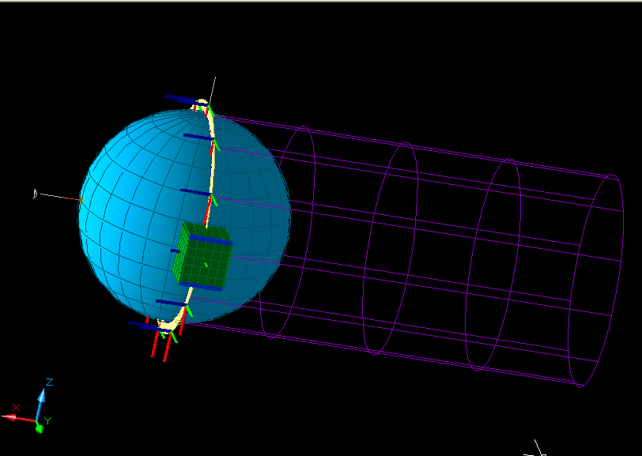
Figure 8: Orbit with Beta angle of ninety degrees

The hot case, as previously mentioned, is the condition of extreme heat generated and transferred by and to NANOSATC-BR2. The internal equipment are considered operational and dissipating as much heat as they are able. The simulation results are split into steady state, when it is done an average of all heat loads throughout the CubeSat’s orbit, and transient, when the heat loads are evaluated through the time. The Figures 9 and 10 show the steady state results for the cold case whereas the Figures 11,12,13,14,15,16 show the payload system, communication system, frame structure, OBC system, strucutral panels and power system results for transient case. The transient model have simulated just a 6500 seconds path, with corresponds to just one orbit. It was done in order to diminish the computational load through the simulation, since the pattern will repeat after 6500 seconds

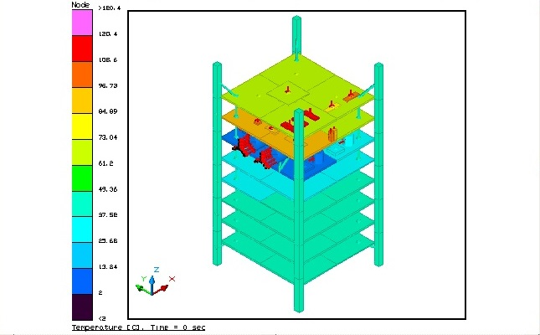
Figure 9: Steady State of NANOSATC - BR2 without structural panels in the hot case

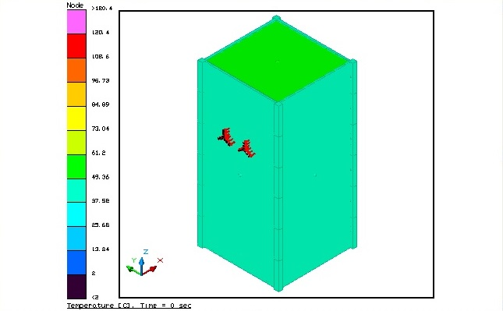
Figure 10: Steady State of NANOSATC - BR2 with structural panels in the hot case

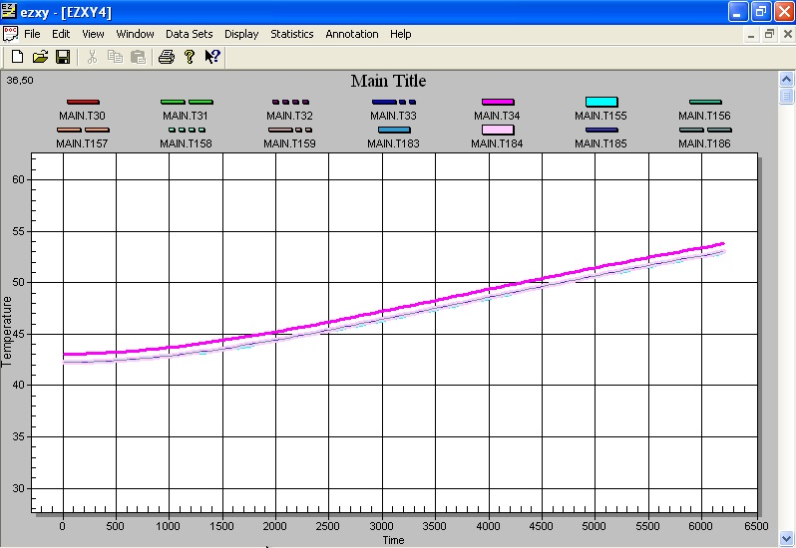
Figure 11: Temperature variation graph Payload System of NANOSATC-BR2 at hot case

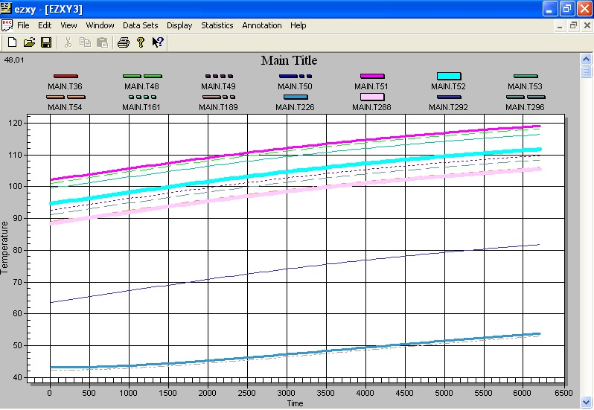
Figure 12: Temperature variation graph Communication System of NANOSATC-BR2 at hot case

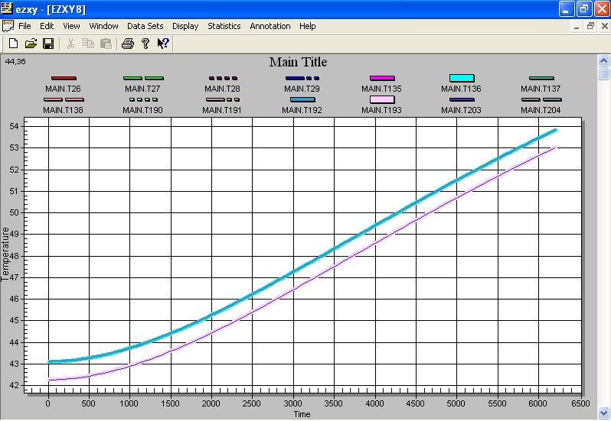
Figure 13: Temperature variation graph Frame Structure of NANOSATC-BR2 at hot case

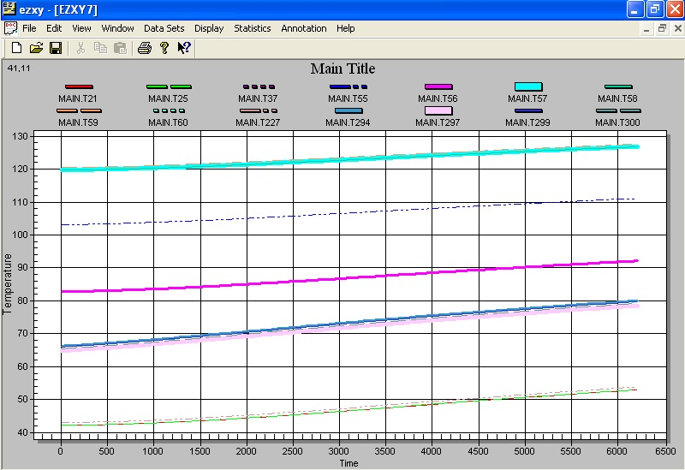
Figure 14: Temperature variation graph On Board Computer of NANOSATC-BR2 at hot case

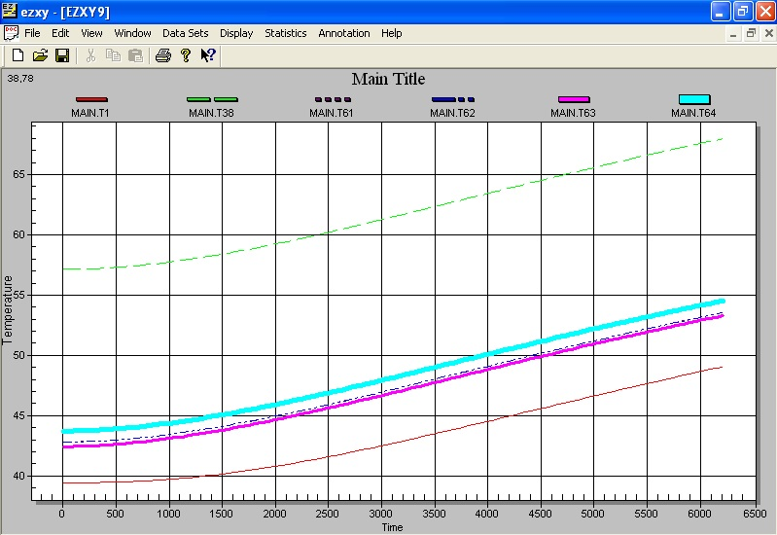
Figure 15: Temperature variation graph Structural
Panels of NANOSATC-BR2 at hot case

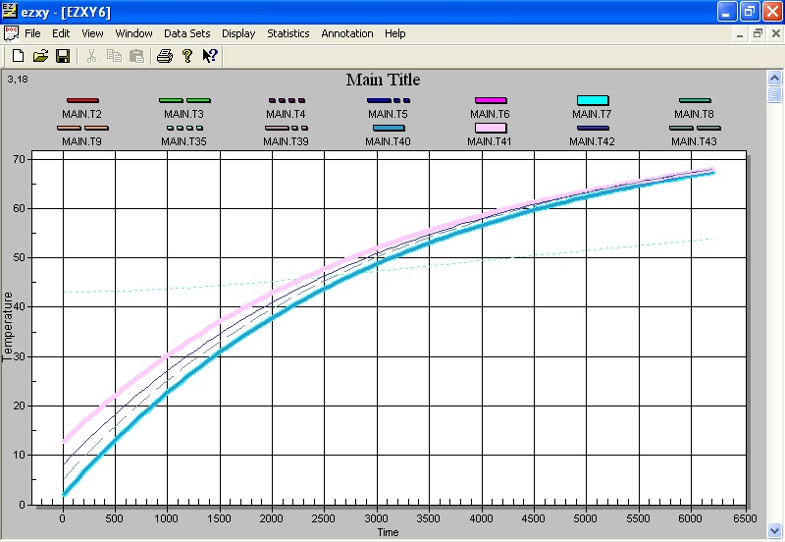
Figure 16: Temperature variation graph Power System of NANOSATC-BR2 at hot case

Cold case: All subsystems in standby mode and orbit LEO (low Earth orbit) with beta angle of 0 degrees, according Gilmore (1994), [4]. This orbit has the characteristic of maintaining the satellite in the Earth shadow longer. The Figure 17, below, shows the orbit of the Cold Case (Purple cylinder is the part of the orbit where the satellite is in Earth's shadow).

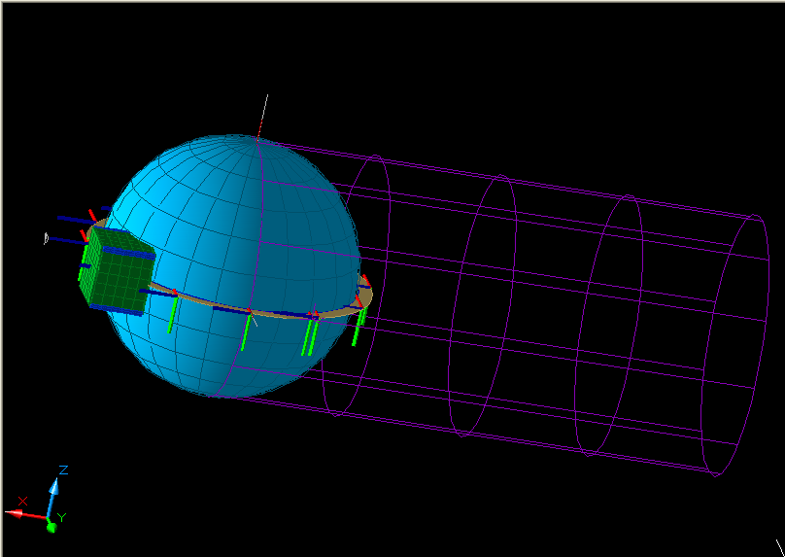
Figure 17: Orbit with Beta angle of zero degrees

In the cold case, as mentioned earlier, the minimum standard of heat generated and transferred by and to NANOSATC-BR2 is considered. The internal equipment are considered operational and dissipating the smallest amount of heat, they are capable. The simulation results are split into steady state, when it is done an average of all heat loads throughout the CubeSat’s orbit, and transient, when the heat loads are evaluated through the time. The Figures 18 and 19 show the steady state results for the cold case whereas the Figures 20,21,22,23,24,25 show the payload system, communication system, frame structure, OBC system, strucutral panels and power system results for transient case. The transient model have simulated just a 6500 seconds path, with corresponds to just one orbit. It was done in order to diminish the computational load through the simulation, since the pattern will repeat after 6500 seconds
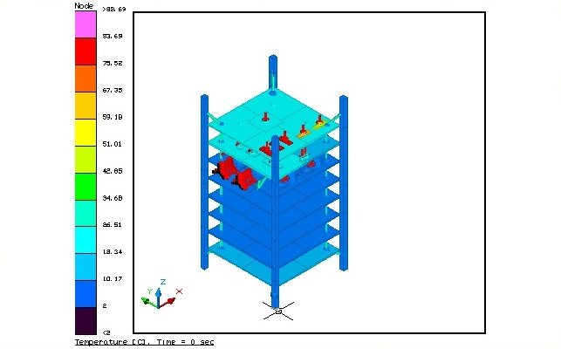
Figure 18: Steady State of NANOSATC - BR2 without structural panels in the cold case

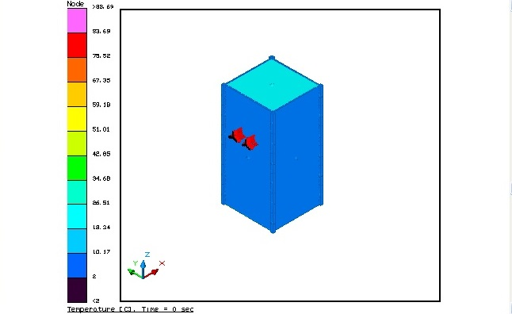
Figure 19: Steady State of NANOSATC - BR2 without structural panels in the cold case

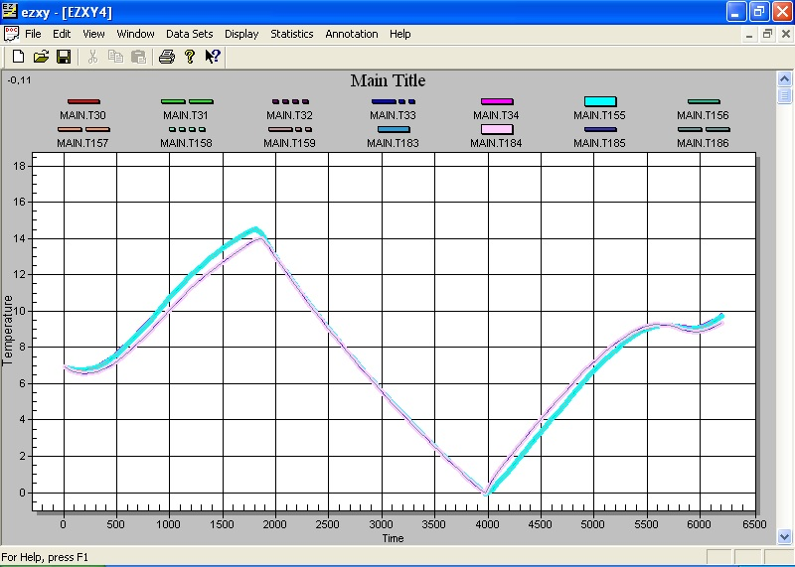
Figure 20: Temperature variation graph Payload System of NANOSATC-BR2 at cold case

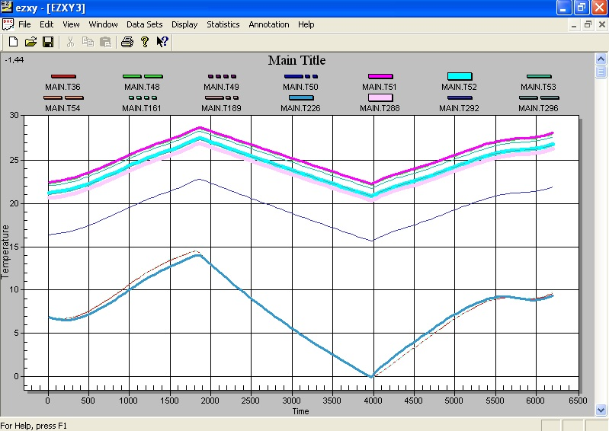
Figure 21: Temperature variation graph Communication System of NANOSATC-BR2 at cold case

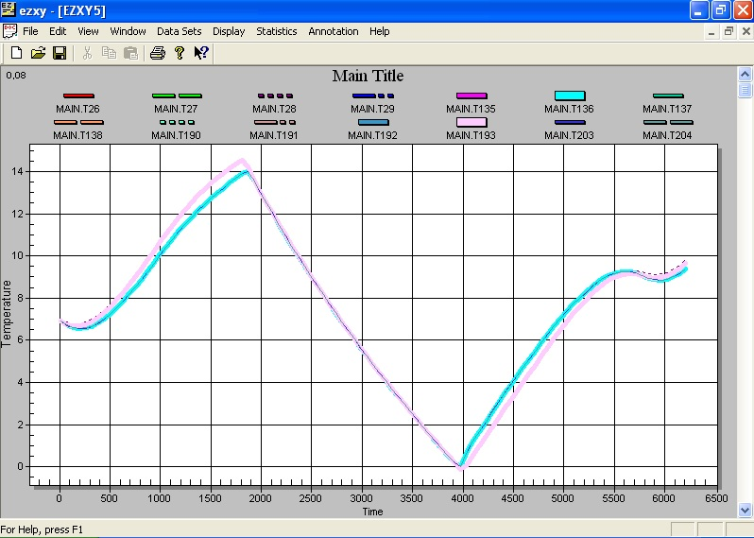
Figure 22: Temperature variation graph Frame Structure of NANOSATC-BR2 at cold case

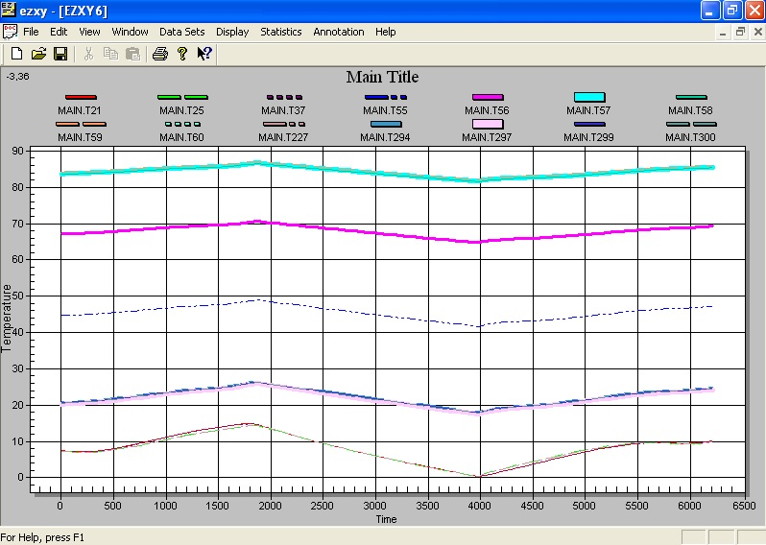
Figure 23: Temperature variation graph On Board Computer of NANOSATC-BR2 at cold case

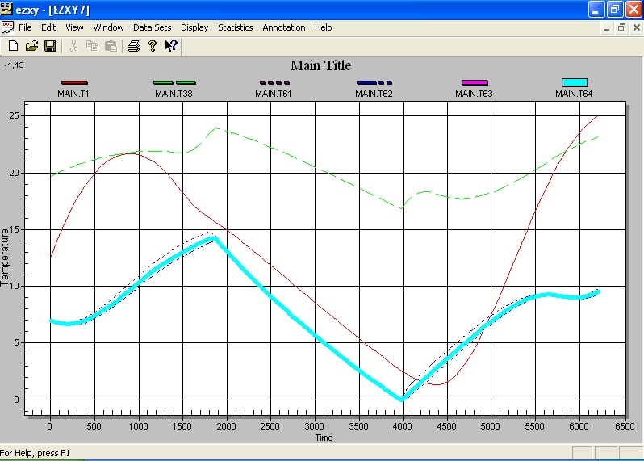
Figure 24: Temperature variation graph structural panels of NANOSATC-BR2 at cold case

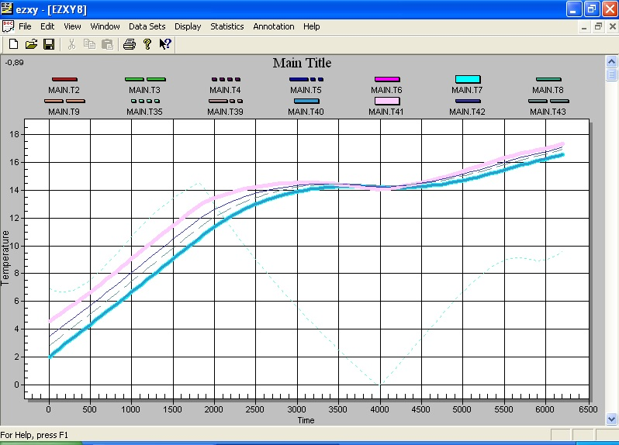
Figure 25: Temperature variation graph Power System of NANOSATC-BR2 at cold case

According to the manufacturer of each equipment, there is a defined temperature range in which the devices can normally work on. For the subsystems of NANOSATC-BR2, follow a table below the permissible temperature variations of each subsystem. According Leite & Muraoka (1993), [3], all the energy received by an equipment, turns into thermal energy.

Operation
Equipment | Minimum Temperature (°C) | Maximum Temperature (°C)
On Board Computer | -40 | +60
Power System  Charge temperature  Discharge temperature  Storage temperature | -5  -20  -20 | +45  +60  +20
Solar Panels | -85 | +85
Communication System | -10 | +40
Payload System | -40 | +125
Table 4: Permissible temperature variations of each subsystem

- Conclusion

The NANOSATC-BR2 thermal simulation has shown that all internal equipment will perfectly work, since the orbital parameters used are the extreme ones (the hottest and the coldest). In this case, the use of thermal control has been unnecessary for the safety of the mission. Nevertheless, as this simulation was performed with few elements, in order to prevent the high computational cost, it is highly recommended further simulations and thermal tests in order to enhance the accuracy of thermal analysis regarding NANOSATC-BR2 mission.

References

[1] DE SOUSA, F. L., MURAOKA, I. & VLASSOV, V. Ciclo de Palestras Sobre Controle Térmico de Satélites. INPE-11246-PUD/138. 2003-04.

[2] SCHUCH N. J. e DURÃO O. S. P. Documento De Status De Revisão De Engenharias E Tecnologias Espaciais - Projeto NANOSATC-BR – Desenvolvimento De Cubesats. 2011.

[3] LEITE, R. & MURAOKA, I.,Curso Controle Térmico de Satélites. Ministério da Aeronáutica – Dep. de Pesquisas e Desenvolvimento, 1993. p. 74.

[4] GILMORE, D. G., “Satellite Thermal Control Handbook”. 2ª ed. Aerospace Corporation, California, EUA. 1994.

