IAA-XX-14-0S-0P
The NANOSATC-BR1 Electrical Power System
Tális Piovesan *, Leonardo Zavareze da Costa* Thales Ramos Mânica*,
Otávio Santos Cupertino Durão **, Nelson Jorge Schuch*

NANOSATC-BR1 is the first Brazilian Scientific University CubeSat launched in 19th June onboard a Dnepr Launcher in the Yasny Launch Base, in Orenburg Region, Russia. The Project has been designed and executed by the NANOSATC-BR, CubeSats Development Program and developed in a partnership between the Southern Regional Space Research Center from the National Institute for Space Research and the Santa Maria Space Science Laboratory, from the Technological Center at the Federal University of Santa Maria (CRS/INPE-MCTI x LACESM/CT-UFSM). The aim of this work is the study of the NANOSATC-BR1 Electrical Power System presenting the technology applied to convert the solar energy into electrical energy, its power budget, the main loads, payload power consumption and the power generation behavior. A comparison is made between the preliminary power generation calculated with mathematical software and the real space orbit measures collected between the 22th June to 8th August, showing also the main technical electrical information like the battery voltage, current, solar cell voltage and current, and satellite temperature in space orbit. The study is important to set the Programs's next and future space mission constraints, like the NANOSATC-BR2 nanosatellite, that is been developed by the Program and the development of new space technologies. Results are presented and discussed in order to comprehend the behavior of the satellite in space orbit and the development of new low cost technologies to apply in other nanosatellites of the Program.
1 Introduction
The NANOSATC-BR1 satellite is the first Brazilian scientific nanosatellite developed and built in a partnership between the Southern Regional Space Research Center from the National Institute for Space Research and the Santa Maria Space Science Laboratory, from the Technological Center at the Federal University of Santa Maria (CRS/INPE-MCTI x LACESM/CT-UFSM). The goals of the project are the contact of students, thecnologists, researchers and universities professors with space technologies, the operation of a space mission, the development of new low cost technologies and the space climate monitoring.
The NANOSATC-BR1 is a 1U CubeSat and its measures are (10x10x10 cm) and it weighs 0,965 kilogram. It was launched in 19th in Yasny Launch Base in a Low Earth Orbit (LEO) and since 22th June it is sending data to the Ground Station (GS) located in Santa Maria - RS GS(INPE-CRS), south of Brazil and São José dos Campos – SP, GS(INPE-ITA) southwest. The Engineering Model (EM) is been shown in Fig. 1.
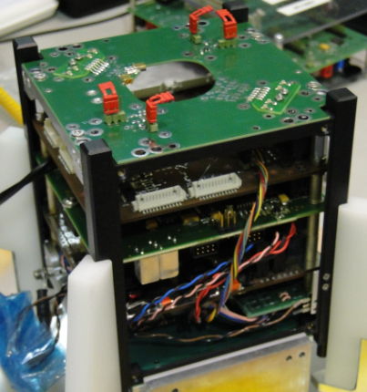
Fig. 1. The NANOSATC-BR1 Engineering Model.
Magnetic sensors and two experiments of Santa Maria design House and Federal University of Rio Grande do Sul are the NANOSATC-BR1 scientific and technological payloads. The magnetic sensor is monitoring the South American Magnetic Anomaly (SAMA) that is a weak region of Earth’s magnetic field located in the South American continent, (Fig. 2). The other two experiments are testing a chip and embedded software in a FPGA, qualifying their functioning in the space environment.
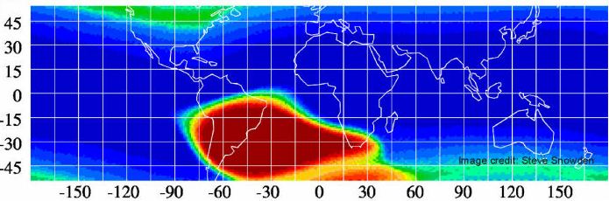
Fig. 2. The Earth’ magnetic field around the Globe.
The red area represents the SAMA.
Source: http://heasarc.gsfc.nasa.gov/docs/rosat/gallery/display/saa.html
The first scientific results are been analyzed and published by the NANOSATC-BR Team confirming the success of the NANOSAT-BR1 mission.
2 The Electrical Power System Unit (EPS)
The electrical power system unit is the system responsible to generate, conditioning, store, control and provide electrical energy to all the satellite. The system is composed of solar panel, DC-DC converters, Li-ion batteries, wires, voltage sensor, current sensor, and a microprocessor, responsible to control the converters’ duty cycle, the maximum power point tracking and the serial connection with the On Board Computer (OBC). ^{[1]}
GOMSPACE is the supplier of the NANOSATC-BR1 EPS and his system is composed by three boost converters to elevate the DC level and charge the Li-ion batteries, resulting 7.4 Volts. Buck converters are used to conditioning the two energy output in 5 and 3.3 Volts, (Fig. 3) .^{[2]}
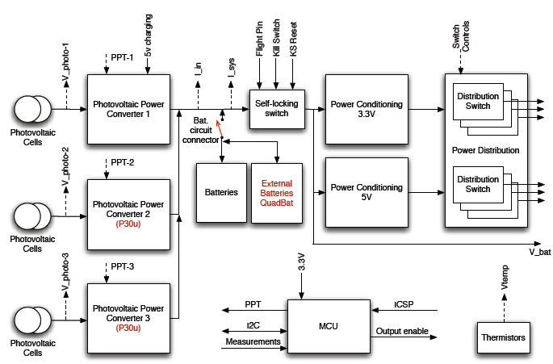
Fig. 3. GOMSPACE’ EPS topology. Source:[2]
2.1 Power Generation
NANOSATC-BR1 presents 12 multi junction solar cells with 28% of efficiency in the 6 faces to convert the solar energy in electrical energy. Patel (2005) declare that the only power source in the space environment is the solar radiation, then any system that do not use the solar energy have to carry his own power source, like primary battery nuclear energy or a fuel cell.^{[1]}
The photoelectric effect have been discovered by Edmond Becquerel in 1839 and since the first satellite developed by the URSS have utilized solar cells to feed the chemical batteries almost all the satellites make the solar conversion as the main way to get energy.^{[3]}
A solar cell is represented by an equivalent electrical circuit showed in Fig.4 where Villalva (2009) describes the amount of current that the solar cell is going to convert by a specific incident light, in equation [1].
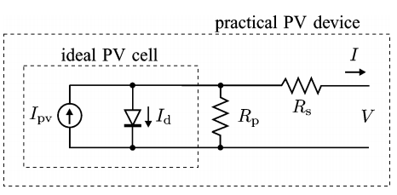
Fig. 4. Solar Cell’ equivalent electrical circuit. Source:[4]
To increment the solar cells’ power generation is been used in photovoltaic applications the MPPT algorithm that track the maximum power point changing the operational point of the cell. When the boost converter is used the duty cycle increases when the recent power generated is higher than the previous power generated.^{[5]} The maximum power point is shown in Fig.5.
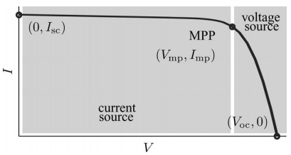
Fig. 5. Solar cell maximum power point. Source:[4]
Considering the best case of power generation with 90% efficiency; 400 mA solar current; 65% of the time in a LEO orbit (approximately 60 minutes) the period of solar insolation; the amount of power generated will be equal to 2.67 Watts or 149886 Joules.
2.2 Power Conditioning
Power conditioning in DC-DC current is possible making the use of DC-DC converters, where these devices are compared to a transformer in AC current.^{[6]}
Boost converter is a DC-DC converter that is responsible to raise input voltage, where it circuit is been shown in Fig. 7 and the output voltage is proportional to the switch duty-cycle (d), seen in [2].
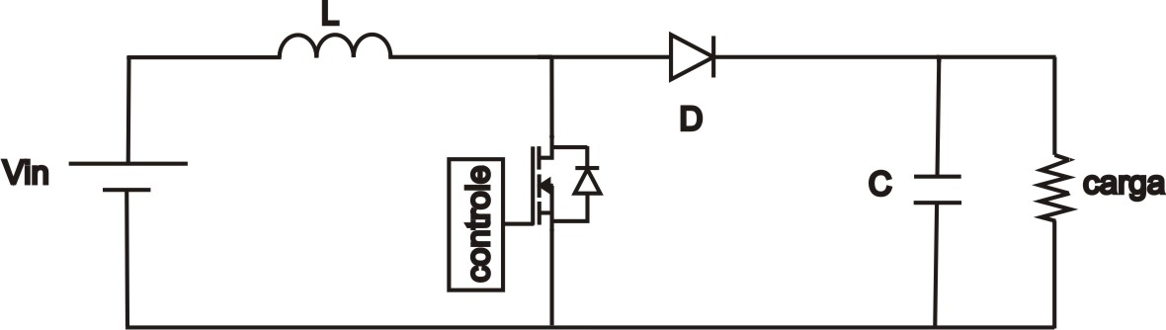
Fig. 7. Boost converter electrical circuit.

 | $$V_{out}=\frac{V_{in}}{1-d}$$ | [2]
To step down the battery voltage to 5 and 3.3 Volts the EPS employs 2 buck converters, (Fig. 8), where the output is directly dependent of the switch duty-cycle, [3].
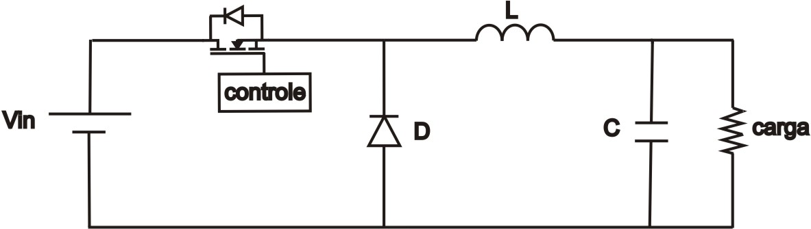
Fig. 8. Electrical circuit of the buck converter

 | $$V_{out}=dV_{in}$$ | [3]
2.3 Main Loads
The satellite is divided in two categories of equipment, the bus and the payload. The bus comprehend the physical structure and all the vital systems to the satellite be switched on and maintain the contact with the ground station. The bus subsystems are the EPS, Attitude Determination and Control System (ADCS), telecommunications, antenna and the On Board Computer (OBC). The payload is defined by the space mission program and usually is a camera, software, sensor, circuits or other equipment.
The NANOSATC-BR1 main loads are described in Table 1, where the TRXUV RX is the the radio receiver and TRXUV TX is the radio transmitter.

Subsystem | Current consumption from battery bus 7.5V [mA] | Power [mW] | Duty Cycle [%] | Energy cunsu-med in 1h [Wh] | Energy per 24h [Wh]
EPS | 33.3 | 249.75 | 100 | 0.2497 | 5.994
Antenna | 5.33 | 39.975 | 100 | 0.0399 | 0.959
OBC | 30.8 | 231 | 100 | 0.231 | 5.544
TRXUV RX | 30 | 225 | 100 | 0.225 | 5.4
Payload Housekeep-ing and magneto-meter | 20 | 150 | 100 | 0.15 | 3.6
Payload MIPS and SMDH | 30.9 | 231.75 | 100 | 0.2317 | 5.562
TRXUV TX | 105 | 787.5 | 0.3 | 0.0023 | 0.056
Amount |  |  |  | 1.13 | 27.11

Table 1 – Main loads of the NANOSATC-BR1 CubeSat

3 Data Analysis
It is been received usually 2 times a day the data from the CubeSat, where the packets are the beacon, housekeeping, error, magnetometer, and the two experiments. The author have made an analysis of the beacon data the topics related to power expenditure, electrical power generation, battery voltage and temperature among 22th June to 22th Semptember 2014. Results are visualized in Fig.9, Fig.10, Fig.11, Fig.12 where the X axis is not a continuous time.

Fig. 9. NANOSATC-BR1’ battery voltage among 22th June to 22th Semptember 2014. The X axis is not a continuous time.

Fig. 10. NANOSATC-BR1’ Currents from 22th June to 22th Semptember 2014. The blue line represent the total system current (mA), red is the PV current (mA), green is the TRXUV RX current (mA).

Fig. 11. NANOSATC-BR1’ internal temperature in Celsius Degrees from 22th June to 22th Semptember 2014.

Fig. 12. NANOSATC-BR1’ photovoltaic voltage and current from 22th June to 22th Semptember 2014. The blue line represent the photovoltaic voltage (mV), red line is the PV current (mA).
4 Results and Conclusions
NANOSATC-BR1’ technical telemetry space data have shown a normal behavior in space orbit related to electrical characteristics. Have been noticed that after some unknown event the battery voltage have started to drop because of the electrical power generation decrease compared to the space mission’ start. Now the satellite is operating in a safe mode because of the battery low level and the data is been sent, telemetry, in a Morse code mode.
Concluding this present work is recommended to discover the effect that occurred during the satellite operation to affirm that the next space mission of the NANOSATC-BR Program will work normally in a nominal mode, acquiring during all the time valid data.
5 Future Challenges
The presented work has the future challenges to monitor the NANOSATC-BR1 Engineering Model to increase the reliability of the data given by the satellite datasheets, providing the real power consumption of all the operational modes.
The author is been studying and developing a new energy power supply system to apply in the future space missions of the NANOSATC-BR Program. The first prototype is been tested in the Federal University of Santa Maria at the Technological Center 's Laboratories and the results are going to be shown to the Scientific Academy. The first prototype has the objective to test the topology and verify the efficiency of the circuit. The next step in the project will be the increasing of the efficiency and reliability to Single Event Effects (SEE) which are caused by the collision of electrical particles in the electrical circuit.
6 Acknowledgements
The authors acknowledge the PCI-DE Scholarship Program from the MCTI(INPE-CNPq) for the financial support to the presented work and the CRS/INPE-MCTI for the laboratories and infrastructure support and the permission to use all the NANOSATC-BR1 technical information and orbit data.
References
[1] PATEL, M. R. Spacecraft Power System. CRC PressINC, New York, 2005.
[2] GOMSPACE. NanoPower P-series Datasheet P31 V6.1. Denmark, 2012.
[3]LYNN, P. A. Electricity from Sunlight: An Introduction to Photovoltaics. John Wiley & Sons Ltd, Imperial College London, 2010.
[4] VILLALVA, M. G.; GAZOLI, J. R.; RUPPERT FILHO, E. Comprehensive Approach to Modeling and Simulation of Photovoltaic Arrays. IEEE TRANSACTIONS ON POWER ELECTRONICS, VOL. 24, NO. 5, MAY 2009.
[5] MOÇAMBIQUE, N. E. M. Aplicação de Algoritmos de Busca do ponto de Máxima potência e controladores lineares e/ou Fuzzy para a regulação da tensão terminal de Paineis Fotovoltaicos. Dissertação de Mestrado da Universidade de São Paulo, São Carlos, 2012.
[6] RASHID, M. H. Eletrônica de Potência, Circuitos, Dispositivos e Aplicações. MAKRON Books, São Paulo, 1999.

* Southern Regional Space Research Center - CRS/INPE-MCTI in collaboration with the Santa Maria Space Science Laboratory - LACESM/CT - UFSM, Santa Maria, RS, Brazil. talispiovesan@gmail.com, leonardozavareze@gmail.com, thalesrmanica@gmail.com, njschuch@gmail.com
** The Brazilian Institute for Space Research - INPE/MCTI, São José dos Campos, Brazil, otavio.durao@inpe.br

