IAA-XX-14-0S-0P
NANOSATC-BR1 Launch Process and Technical Management
Leonardo Zavareze da Costa * Tális Piovesan *, Thales Ramos Manica*,
Otávio Santos Cupertino Durão **, Nelson Jorge Schuch*
The Brazilian NANOSATC-BR Team***.
A NANOSATC-BR1 is the first Brazilian scientific university nanosatellite from the NANOSATC-BR, CubeSats Development Program. This Program aims to capacitate Brazilians human resources in the satellite development and space researches areas by designing, developing platforms and payloads, test, launch and operate national scientific nanosatellites, which will follow CubeSats standards. The Project has been designed and executed in a partnership between the Southern Regional Space Research Center (CRS) from the National Institute for Space Research (INPE-MCTI); the Santa Maria Space Science Laboratory, from the Federal University of Santa Maria (UFSM); the Santa Maria Design House (SMDH); the Graduate Program in Microelectronics from the Federal University of Rio Grande do Sul (MG/II/UFRGS); and the Aeronautic Institute of Technology (ITA/DCTA/CA-MD). This paper aims to present the NANOSATC-BR1 launch mission, launch process and the technical management between the Project’s teams (Brazilian delegation, in Russia x Tracking and Control Team, in Brazil) to find and track the CubeSat in space in his initial orbits with the Program’s Ground Stations systems. The NANOSATC-BR1 was launched in 19th June 2014, by a Russian Launcher DNEPR, in the ISL07 VIP Event, in Yasny Launch Base, Yasny, in Orenburg Region, Russia, and is already in nominal mode, receiving and transmitting data. The launch mission has sent a Brazilian delegation compose by two Researchers from INPE-MCTI and CRS/INPE-MCTI, Dr. Otávio Santos Cupertino Durão and Dr. Nelson Jorge Schuch, and two students from the UFSM, Leonardo Zavareze and Tális Piovesan, to the launch place to monitor the process. The results are presented in this work with NanosatC-BR1’s in orbit telemetry samples. To present the technical management between the teams during the launch is important for Program’s future missions, as NANOSATC-BR2, and other projects missions.
1. The Brazilian NANOSATC-BR Team

1 - Nelson Jorge Schuch, 2 - Otávio Santos Cupertino Durão, 3 - Alexandre Álvares Pimenta, 4 - Polinaya Muralikrishna, 5 - Adriano Petry, 6 - Marlos Rockenbach da Silva, 7 - José Valentin Bageston, 8 - Odim Mendes Jr, 8 - Nalin Babulau Trivedi, 9 - Severino Luiz Guimarães Dutra, 10 - Alisson Dal Lago, 11 - Clezio Marcos Denardini, 12 - Ezequiel Echer, 13 - Luis Eduardo Antunes Viera, 14 - Geilson Loureiro, 15 - Maria de Fátima Francisco Mattiello, 16 - Mario Celso de Almeida, 17 - Valdemir Carrara, 18 - José Sergio de Almeida, 19 - Helio Kuga, 20 - Rafael Lopes Costa, 21 - Lucas Lopes Costa, 22 - Natanael Rodrigues Gomes, 23 - Renato Machado, 24 - Andrei Piccinini Legg, 25 - João Baptista dos Santos Martins, 26 - Ricardo Reis, 27 - Fernanda Gusmão de Lima Kastensmidt, 28 - Rubens Zolar Gehlen Bohrer, 29 - Eduardo Escobar Bürger, 30 - Cassio Espindola Antunes, 31 - Tardelli Ronan Coelho Stekel, 32 - Carlos Roberto Braga, 33 - Juliano Moro, 34 - William do Nascimento Guareschi, 35 - Claudio Machado Paulo, 36 - Fernando Landerdahl Alves, 37 - Lucas Lourencena Caldas Franke, 38 - Mauricio Ricardo Balestrin, 39 - Guilherme Paul Jaenisch, 40 - Iago Camargo da Silveira, 41 - Rodrigo Passo Marques, 42 - Tális Piovesan, 43 - Jose Paulo Marchezi, 44 - Tiago Bremm, 45 - Vinicius Deggeroni, 46 - Leonardo Zavareze da Costa, 47 - Pietro Fernando Moro, 48 - Thales Ramos Mânica, 49 - Anderson Vestena Bilibio, 50 - Andreos Vestena Bilibio, 51 - Tiago Travi Farias, 52 - Marcos Antonio Laurindo Dal Piaz, 53 - Lauro Barbosa Alves, 54 - Pablo Ilha Vaz, 55 - Elói Fonseca, 56 - Lidia Hissae Shibuya Sato, 57 - Marcelo Henrique Essado de Morais, 58 - Cristiano Strieder, 59 - Fernando Sobroza Pedroso.

2 Introduction

NANOSATC-BR1 is the first Brazilian scientific nanosatellite from the NANOSATC-BR, CubeSats Development Program. The Program consists of a Capacity Building Integrated Program on space science, engineering and computer sciences for the development of space technologies using CubeSat satellites[1]. NANOSATC-BR1 was launched in 19th June, 2014, by a DNPER launcher, at Yasny Launch Base, RU. Since the launching, the Project has already a large database from the three payloads (one magnetometer: XEN-1210 and two radiation resistant chips: MIPS and SMDH) and it is already been under analysis by the Team's researchers and technologists. The first data received analysis results refer to the magnetometer payload and are shown in Figure 1. This figure is a composition of the data received by the NANOSATC-BR1 in a complete orbit with the IGRF-IAGA/IUGG Earth's magnetic field model. The received data is very close to the Earth's magnetic field model, validating the operation of the scientific payload aboard the CubeSat.

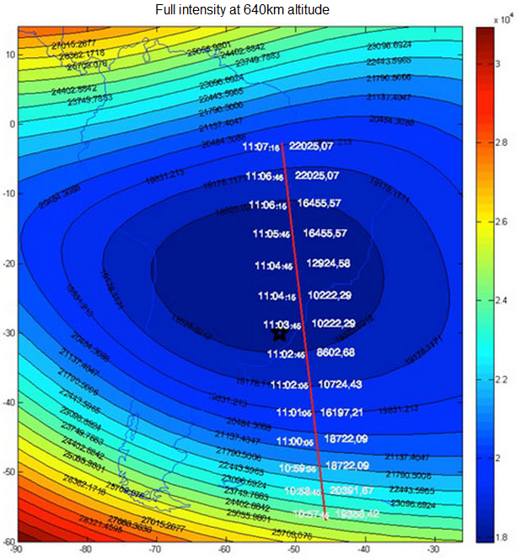

Figure 1. Comparison of the data received from the magnetometer scientific payload in a complete orbit of NANOSATC-BR1 with the IGRF-IAGA/IUGG Earth’s Magnetic Field model.

3 NANOSATC-BR Tracking and Control Ground Stations

The NANOSATC-BR Program have two Ground Stations Systems (GS) installed and operational: (I) GS(INPE-CRS) in the Southern Regional Center for Space Research CRS/ INPE – MCTI, Santa Maria RS, and (II) GS(INPE – ITA), in the Electronic Engineer Building, at the Technological Institute of Aeronautics, ITA/DCTA – MD, in São José dos Campos, SP, Brazil[2]. The both Ground Stations systems are presented in Figure 2.

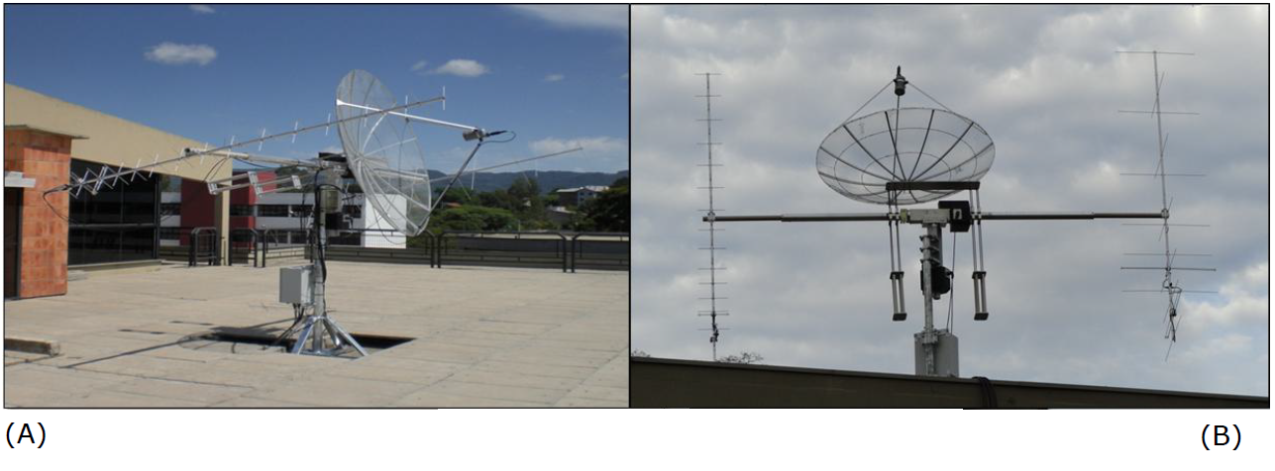
Figure 2. (A) GS (INPE – CRS), in Santa Maria, RS, Brazil, and (B), GS (INPE – ITA), in São José dos Campos, SP, Brazil. Source: NANOSATC-BR Program database.
Both GS systems have similar characteristics (Table 1 & 2) and are able to perform the tracking automatically with preset parameters by the operator. Although it is always necessary that at least one operator is following the tracking. The operating frequency of the GS systems is inside of the amateur radio band established by the IARU.

GS (INPE-CRS) Santa Maria, RS
PARAMETER | VALUE
Frequency range VHF | 144-146MHz
Frequency range UHF | 430-450MHz
Frequency range S-band (receive only) | 2400-2402MHz
Modulation type | SSB (USB and LSB)
 | AM
 | FM
 | CW
Modulation rates | 1200-9600db
Demodulation data rates | 1200-9600db
AC voltage | 230V
AC frequency | 45-65Hz
Uplink Capabilities | 1200db AFSK
 | 9600db G3RUH FSK
Downlink Capabilities | 1200db AFSK
 | 1200db BPSK
 | 9600db G3RUH FSK
VHF antenna gain | 10.2dBdc LHCP / RHCP
UHF antenna gain | 14.1dBdc LHCP / RHCP
S-band antenna gain | 21.4dB RHCP
VHF Noise Figure | 4.2dB
UHF Noise Figure | 4.2dB
S-band converter Noise Figure | 0.9dB typical
Table 1: The GS(INPE-CRS) features
Source: Specs – From ISIS ISIS GSkit Radio Specifications Manual [4]

GS (INPE-ITA) São José dos Campos, SP
PARAMETER | VALUE
Suply voltge | 110 V AC (50-60Hz)  220 V AC (50-60Hz)
Suply current | Max 7.0 A (110 V)  Max 3.5 A (220 V)
Temperature range | 25°C
Relative humidity | 0-90% Non condensing
Weight | 94kg (VHF+UHF)  98kg (including S-band)
TX Frequency range | 144-146MHz (VHF)
 | 435-438MHz (UHF)
Maximum output power | 50dBm (VHF)  50dBm (UHF)
Uplink modulation | AFSK
Uplink datarate | 1200 bps
Uplink protocol | AX.25
RX Frequency range | 144-146MHz (VHF)  435-438MHz (UHF)  2.2-2.5GHz (S-band)
Overal Noise Figure  (cable length 10m) | 1.6dB(VHF)  2dB (UHF)  0.9dB (S-band)
Maximum Input Signal | -20dBm
Downlink modulation | Raised-Cosine BPSK
Downlink datarate | 1.2-9.6 kbps (VHF and UHF)  14.4-115.2 kbps (S-band)
Downlink protocol | AX.25
Table 2: The GS(INPE-ITA) features
Source: Specs – From ISIS ISIS GSkit Radio Specifications Manual [4]

The antennas are connected to a rack that allows the operator to control the entire system from the operating room. The operator can (a) manually set a position of the antennas in the rotors unity; (b) set the radio settings such as frequency and transmission mode, and (c) access the tracking and control softwares. The rack module is shown in Figure 3.

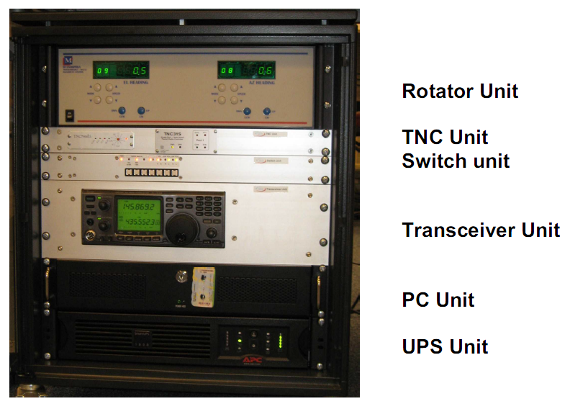
Figure 3. The GS(INPE-CRS) rack control with the rotors control subsystems, radio, transmission units and the central computer. Source: Specs – From ISIS ISIS GSkit Radio Specifications Manual

4 Launching Process

NANOSATC-BR1 launch was performed on June 19, 2014, by ISL / ISIS & ISC-Kosmotras Companies in Yasny Launch Base, Orsk Region, Russia, on a DNEPR launcher. In the same ISILAUNCH 07 Event, (ISL07), 22 nanosatellites, from eight countries including Brazil were launched, totaling 37 satellites of several institutions and companies. NANOSATC-BR1 was the second satellite deployed, together with the QB50p-1 according to the Orbit Injection Parameters shown in Figure 4. A Brazilian technical delegation was sent to the base to accompany the mission launch and manage the technical operations carried out by the Tracking & Control teams in Brazil.

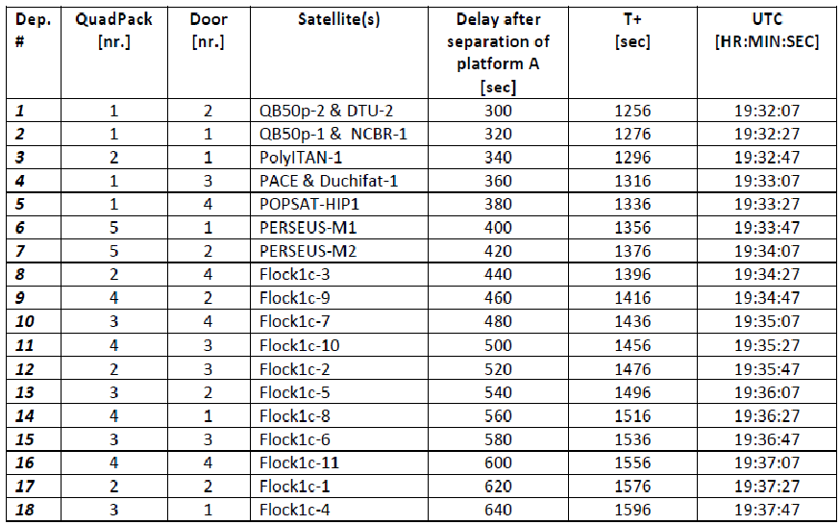
Figure 4. Orbital Injection Parameters, DNPER Launcher.
Source: ISL07 Orbital Injection Parameters 01-05-2014, Table 4-6: CubeSat deployment timing, Pag. 12.

An estimate location for the time of onset satellites ejection by DNEPR launcher is shown in Figure 5. Through this prediction was possible to define the first NANOSATC-BR1 passes over the interest areas and schedule the first operations with GS systems and operators.

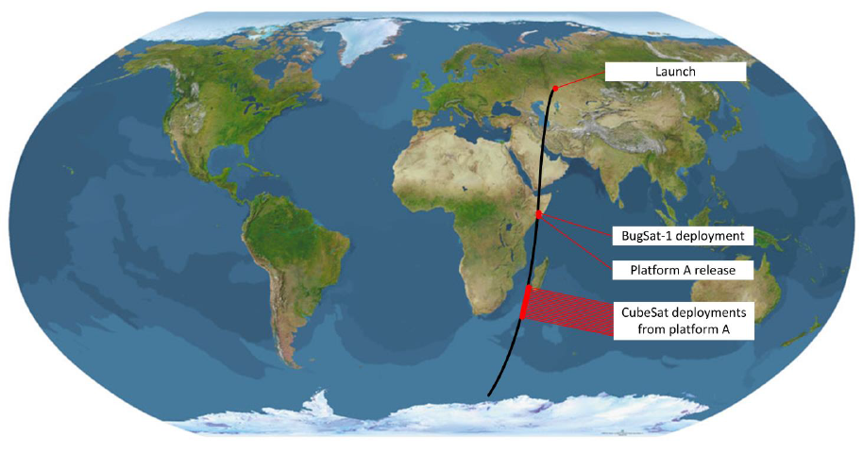
Figure 5. NANOSATC-BR1 – Launching - DNEPR deployment method. Source: ISL07 Orbital Injection Parameters 01-05-2014, Figure 4-1: Impression of ISL07 orbital deployment scheme, Pag. 12 [3].
5 Initial Tracking and Control Procedures

The first operation to be performed after the platform release is to identify the satellite in orbit and verify their physical, thermal and electrical conditions. When the satellite is ejected from the transport platform, it starts automatically in Safe Mode. In this mode the satellite sends signals every 30 seconds in Morse code with basic information about his conditions as battery, temperature and system current.
The operators analyze all information received to set the next activities and commands sent to the satellite. Although, in safe mode the satellite is not enabled to send data payloads if requested. Therefore, it is necessary to change the operation mode to ‘Nominal’. This mode enables all satellite subsystems together with the payloads and allows satellite full functionality. Nominal mode allows the satellite to send signals in hexadecimal mode with more complex information. If the operators detect that the satellite is in disordered movement in orbit 'Detumbling' mode must be triggered. This mode will activate electrical coils placed inside the satellite that will set the satellite orientation with the Earth's magnetic field. Disorderly movement in long period avoid the correctly charge of batteries and subsystems carry out their activities properly. The software used to send commands to the satellite is disclosed in Figure 6.

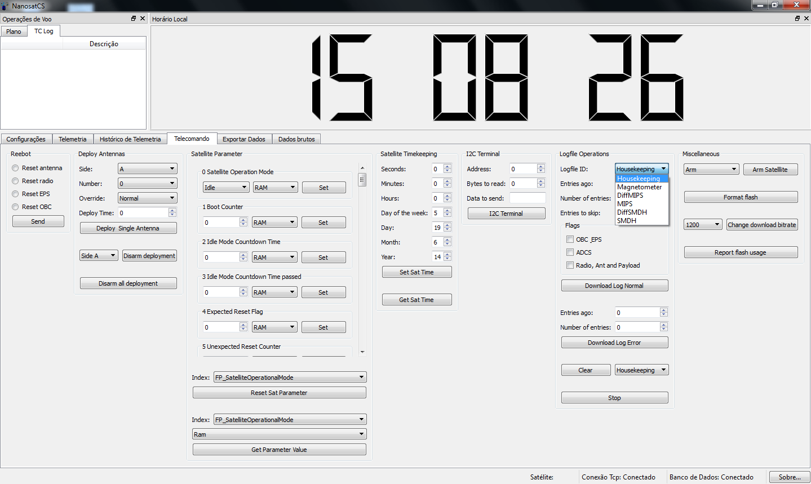
Figure 6. Software developed by EMSISTI used to send commands to the satellite. Source: NANOSATC-BR Program database.

This is the main software for sending remote controls to the satellite. With it the operator can request for payloads data, receive satellite parameters, format the flash memories and change operating modes.
Holding a 7.5 km/sec velocity, 27000 km/h, the NANOSATC-BR1 takes approximately 90 minutes to perform a full orbit, entering in the Program’s Ground Stations Data Acquisition Area four times a day. Each tracking takes about 10 minutes and the maximum data already received in one pass was 500 frames.
After confirmed the correct operation of the satellite and all its subsystems, the operators made Flight Operational Plans. FOPs consists on an activity script to be performed in every tracking. The most common plans involve receiving data from all payloads. Maintenance plans involve the board parameter setting, such as beacon transmission time. A data reception example is disclosed in Figure 7, where the SDRMax software is used to analyze the frequencies and receiving data. In this example, the signal being received is from Housekeeping module at 145.868650 MHz, in 08 October, 2014 – 1059 BRT. Part of the Program database is shown in Figure 8.

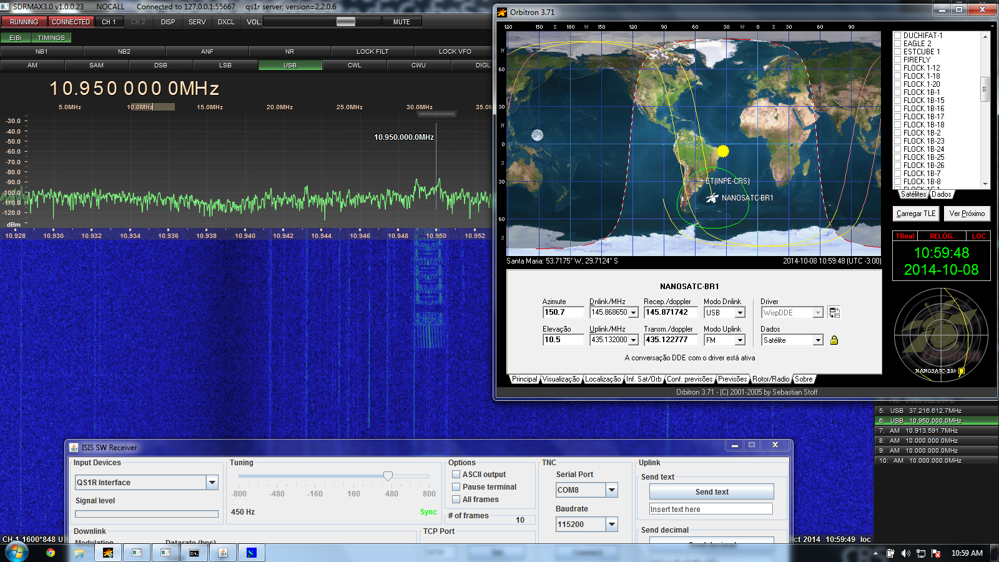
Figure 7. Softwares used to track and control the NANOSATC-BR1. The signal received is from Housekeeping at 145.868650 MHz - 08 October, 2014 – 1059 BRT. Source: NANOSATC-BR Program database.

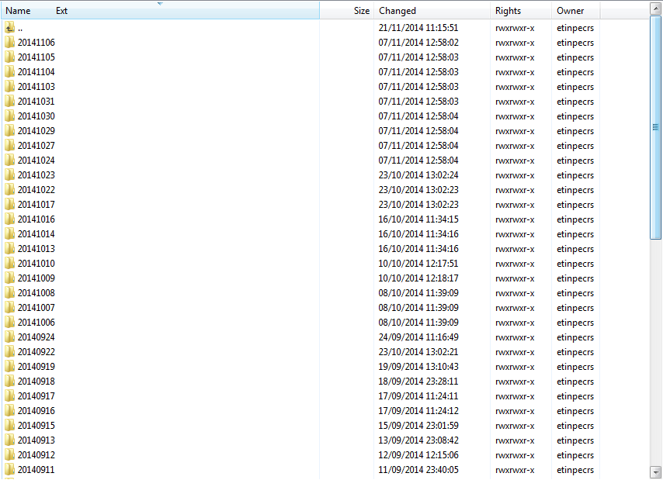
Figure 8. Part of the Program database now available to researchers and involved in the Project. Source: NANOSATC-BR Program database.
6 Results and Conclusions

The mission has already conquered an extensive database, checking the correct operation of all payloads installed in NANOSATC-BR1. All operating procedures and flight plans were improved and operators follow standards activities to control the CubeSat in orbit. The data already received are on analysis and some of them have proven pre-existing theoretical models, like the Earth’s Magnetic Field over the Brazilian territory. The Human Resources Development in the tracking and control activities has been confirmed by the participation of students in scientific events and the publication of works related to these activities.

References

[1] Bürger, E.E et al, "The Launch of the Brazilian INPE/UFSM´s Cubesat – The NanosatC-Br Space Weather Mission", Small Satellites Programmes for Sustainable Development Symposium, UN/Austria/ESA, 2009.

[2] Costa, L. L. et al, "NanosatC-Br – The First Brazilian Cubesat", 59th. IAC, Intl. Astronautical Federation, 2008.

[3] ISL07 – “Orbital Injection Parameters 01-05-2014” – DNPER database.

[4] ISIS GSKits Manuals - GSkit Radio Specifications Manual.

[5] NANOSATC-BR Program Database.

* Southern Regional Space Research Center - CRS/INPE-MCTI in collaboration with the Santa Maria Space Science Laboratory - LACESM/CT - UFSM, Santa Maria, RS, Brazil, leonardozavareze@gmail.com, talispiovesan@gmail.com, thalesrmanica@gmail, njschuch@gmail.com
** The Brazilian Institute for Space Research - INPE/MCTI, São José dos Campos, Brazil, otavio.durao@inpe.br *** Fifty nine persons from: INPE/MCTI, UFSM, SMDH, UFRGS, ITA/DCTA/CA-MD, EMSISTI.

